C PROGRAMMING
NAME : VISHAAL G
REG NO : 1921260043
COURSE CODE : CSA0222

Task 2: Choose the Data Types
2.1 Data-type selection
Data item | Recommended type | Reason
Meter readings | unsigned short | Suitable for a 16-bit meter
Units consumed | unsigned int | Stores non-negative consumption
Household number | unsigned int | Stores positive identifiers
Category | char or enum | Represents a category
Energy charge | long | Stores money in paise
Fixed charge | long | Stores fixed money in paise
Total bill | long | Stores the bill in paise
District grand total | long long | Supports large accumulated totals
Tariff rate | Integer constant | Avoids floating-point money calculations
The exact sizes depend on the system and compiler. The following program prints the sizes and relevant limits:
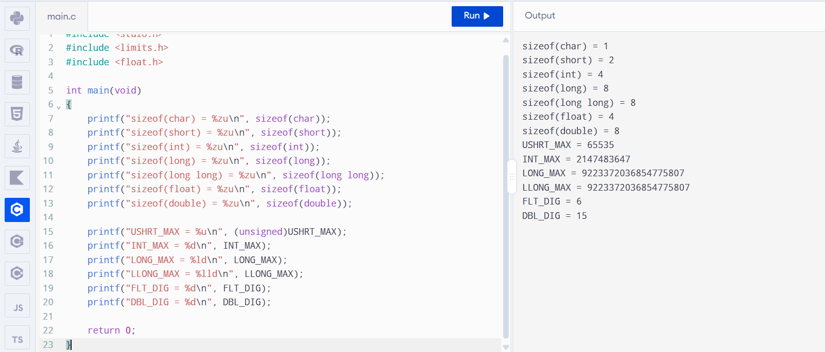
2.2 Why money should be stored in paise
Floating-point numbers cannot represent every decimal fraction exactly. Repeated calculations may introduce small rounding errors. Therefore, ₹162.50 is stored as 16250 paise.
2.3 Float precision example
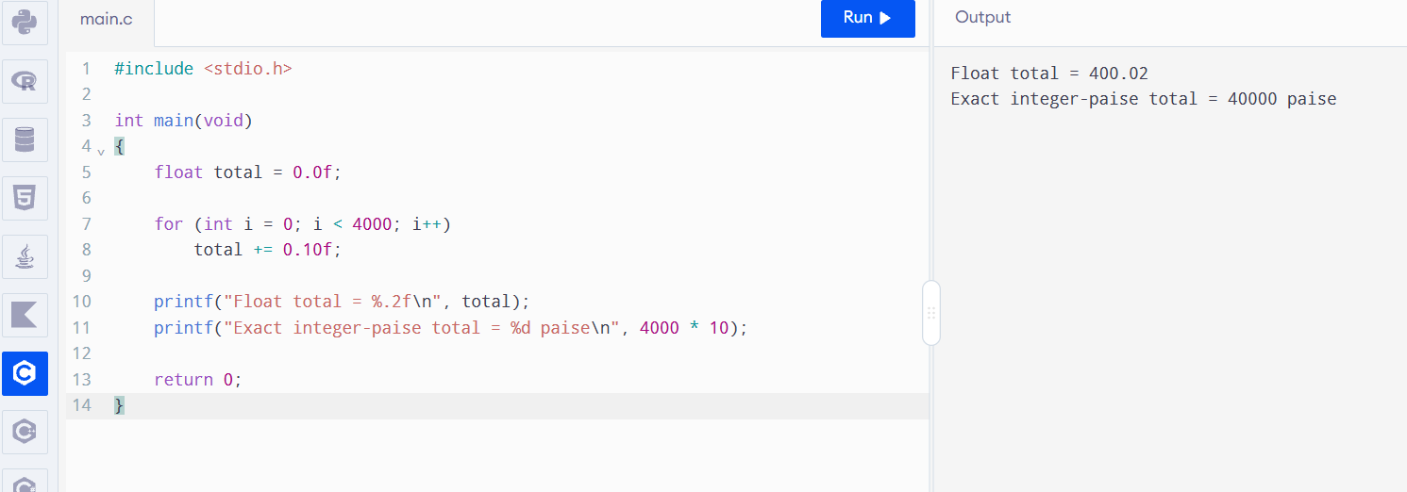
The exact mathematical total is ₹400.00. The floating-point result may differ slightly because of representation and accumulated rounding. The exact printed result depends on the implementation.
The integer-paise approach gives exactly 40,000 paise.
2.4 Meter rollover
Complete TODO 1 as follows:
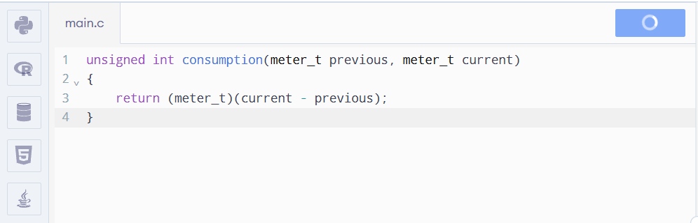
The result is positive because unsigned arithmetic wraps around rather than representing a negative number. This code assumes unsigned short has the expected 16-bit range; the program should verify that assumption on the target system.
2.5 Alternative: double rupees
With double, calculations could be made in rupees, but rounding should occur when converting the final bill into paise, using a defined rounding rule such as rounding to the nearest paisa.
Both integer addition and floating-point addition take \(O(1)\) time. Both types use fixed space per value. However, integer paise avoids the binary floating-point representation errors that can arise with decimal currency.

